CSA1708-ARTIFICIAL INTELLIGENCE
LAB EXPERIMENTS
Program 11 : Python Program for Map Coloring Using CSP
Aim
To write a Python program that colors neighboring regions differently using a Constraint Satisfaction Problem (CSP) and backtracking.
Algorithm
1. Represent each region and its neighboring regions as a constraint map.
2. Create a list of colors and an empty color assignment.
3. Select an uncolored region and try each available color.
4. Check that the selected color is different from every colored neighbor.
5. Assign a valid color and continue recursively to the next region.
6. If a choice leads to failure, undo it and try another color.
7. Display the assignments when all regions are colored.
Program
# Map coloring using CSP and backtracking
regions = {"WA": ["NT", "SA"], "NT": ["WA", "SA", "Q"],
"SA": ["WA", "NT", "Q", "NSW", "V"], "Q": ["NT", "SA", "NSW"],
"NSW": ["Q", "SA", "V"], "V": ["SA", "NSW"], "T": []}
colors = ["Red", "Green", "Blue"]
assignment = {}

def safe(region, color):
return all(assignment.get(n) != color for n in regions[region])
def solve():
if len(assignment) == len(regions):
return True
region = next(r for r in regions if r not in assignment)
for color in colors:
if safe(region, color):
assignment[region] = color
if solve():
return True
del assignment[region]
return False
if solve():
print("Map Coloring Solution:")
for region, color in assignment.items():
print(region, ":", color)

else:
print("No solution found.")
Sample Input
No input is required. The region map and colors are defined in the program.
Program Execution
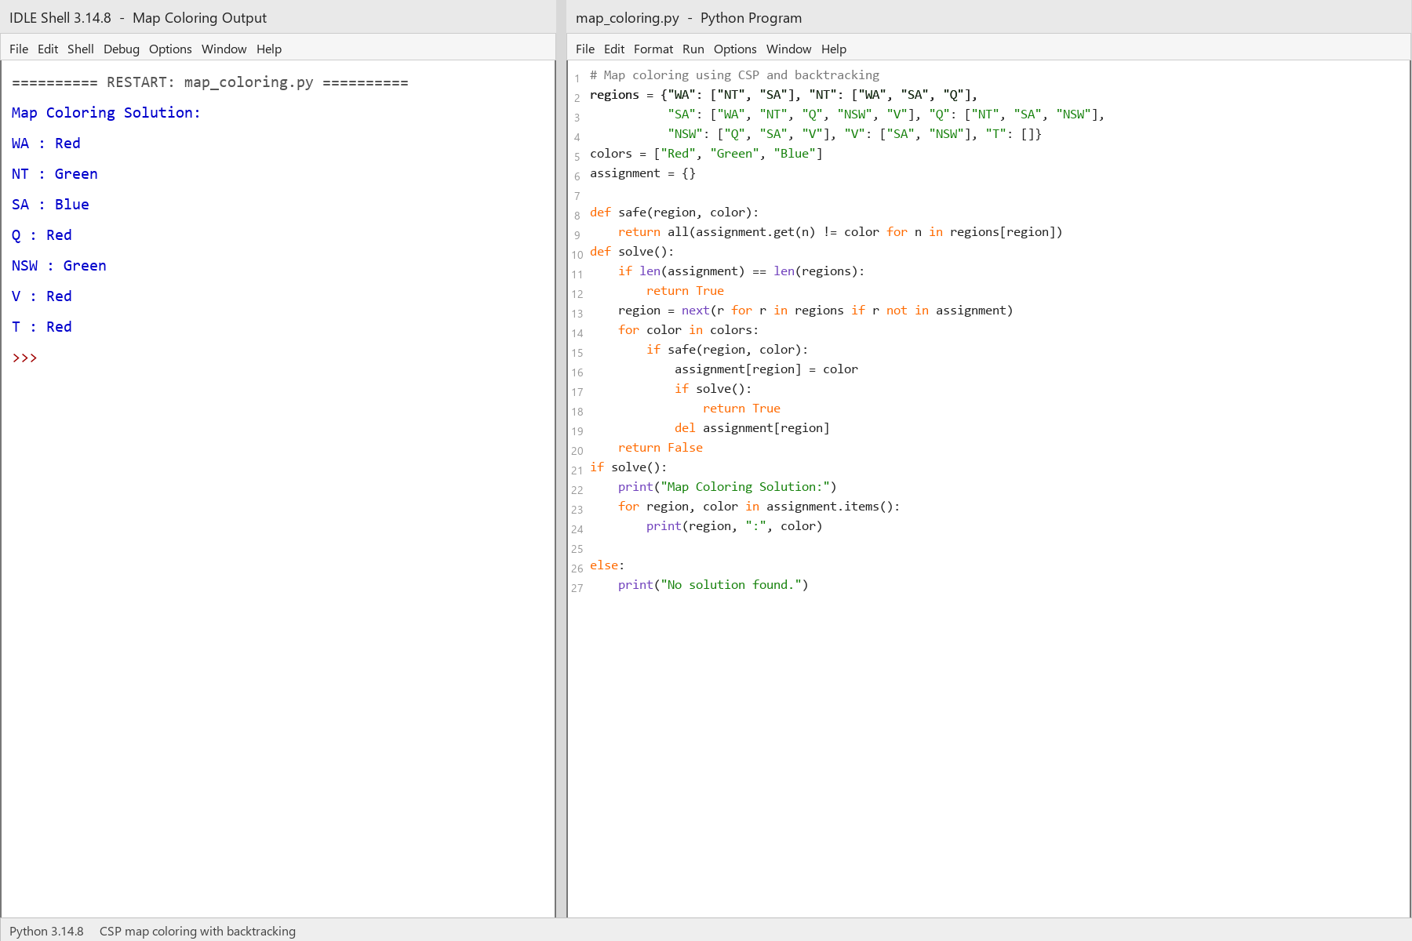
RESULT
Thus, the Map Coloring problem was solved successfully using CSP and backtracking.

